**1.Creating Empty Repository**

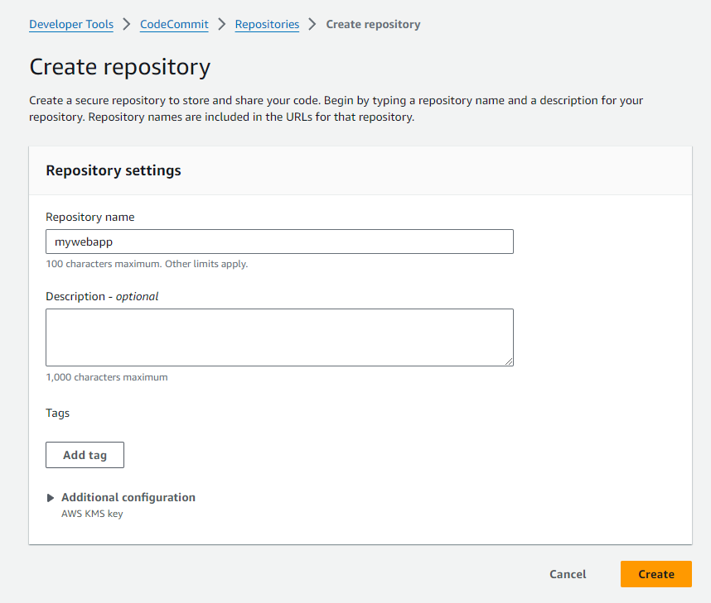

**2.Creating User with Codecommit access Roles**

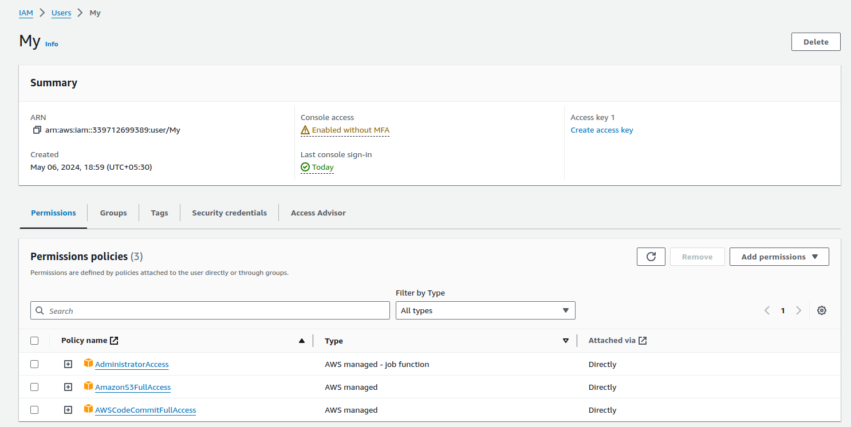

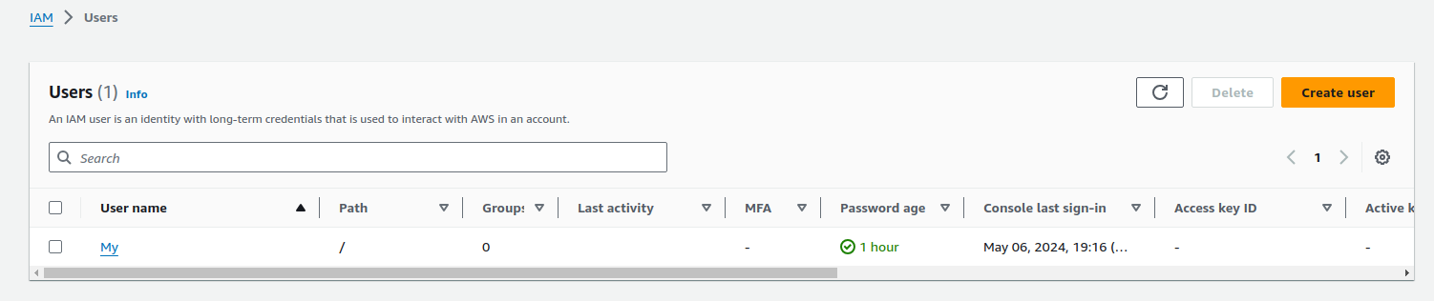

**3.Repository Created**

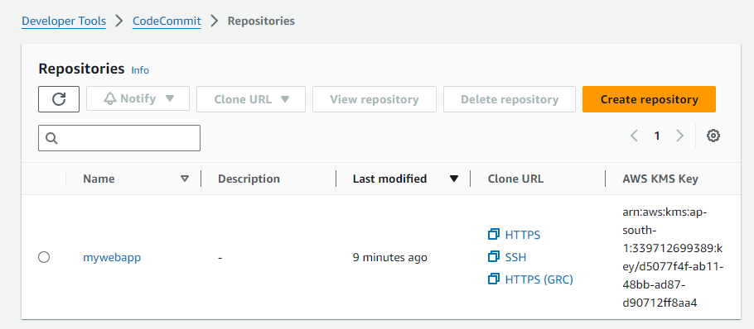

**4.Cloning the Repository with Created user**

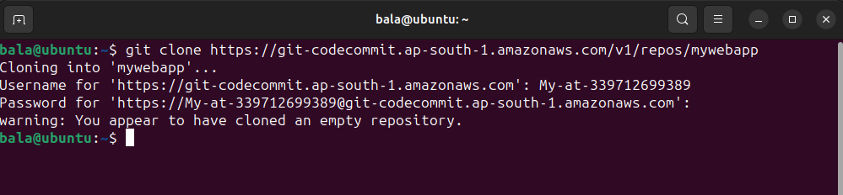

**5.Application files have been created in the Local Repository**

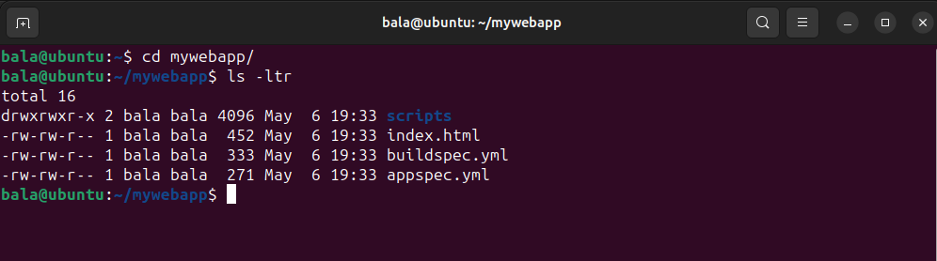

**6.Application files Pushed to AWS Repository**

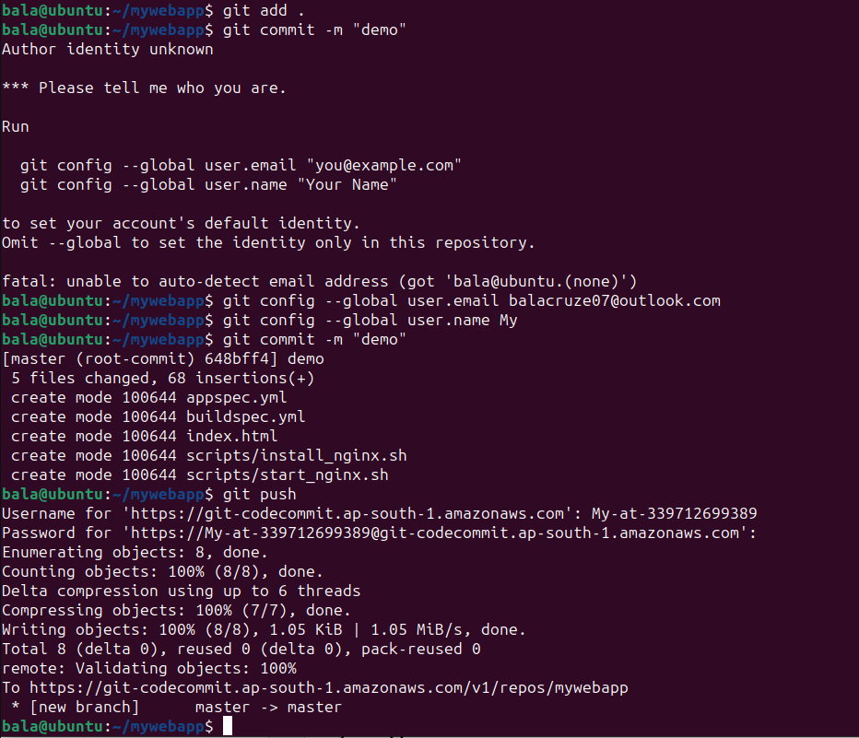

**7.AWS Repository with Required files**

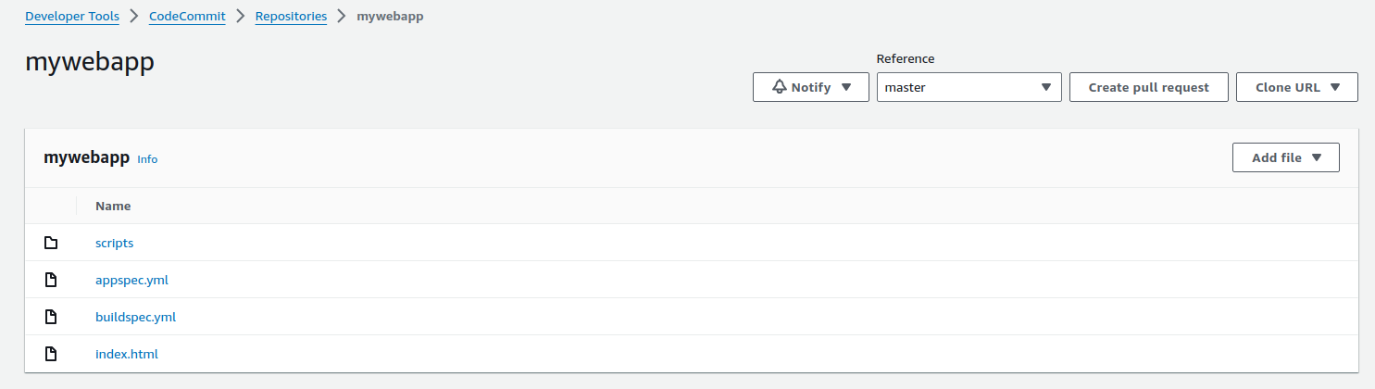

**8.Buildspec file for CodeBuild**

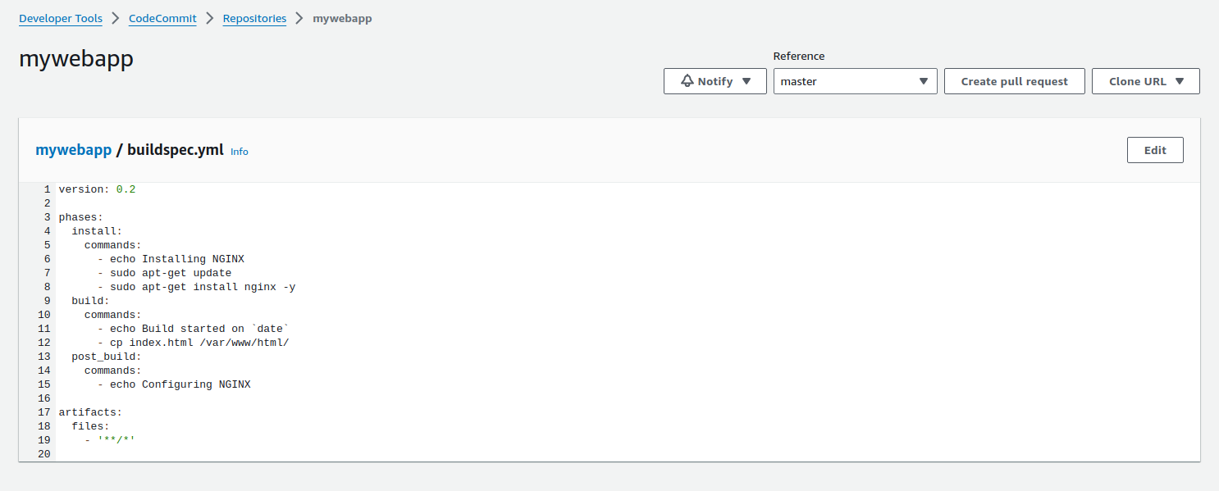

**9.Creating Build Project**

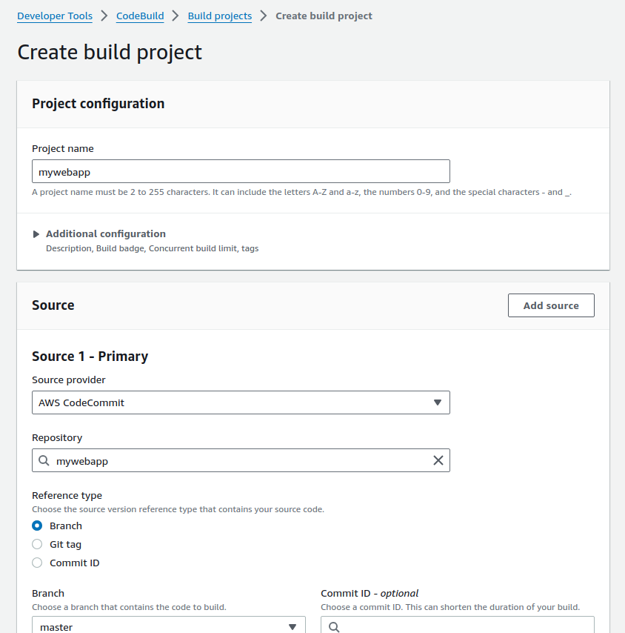

**10.Setting EC2 Environment to create build**

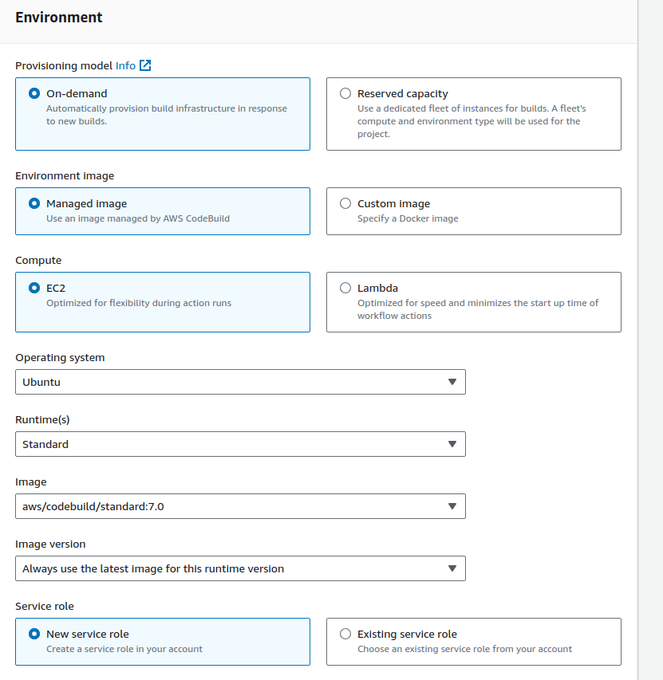

**11.Choosing Buildspec file and S3 bucket for Artifact storage**

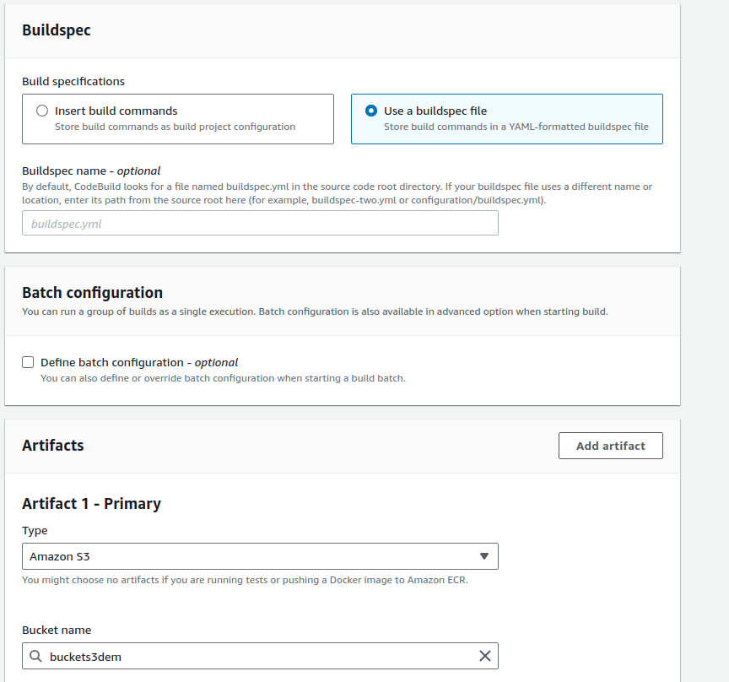

**12.Choosing Logs**

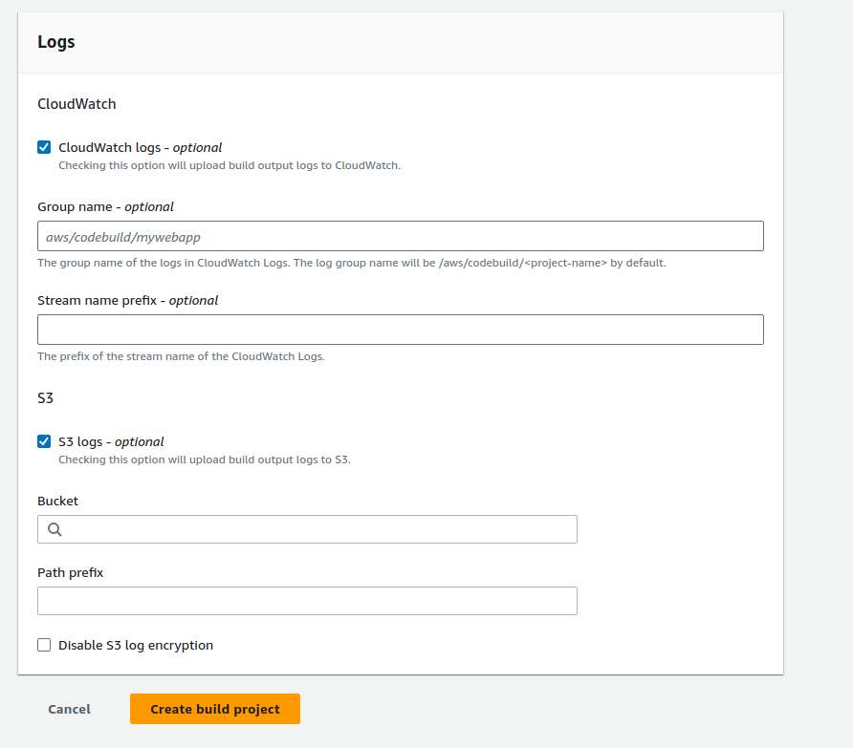

**13.Created Build Project**

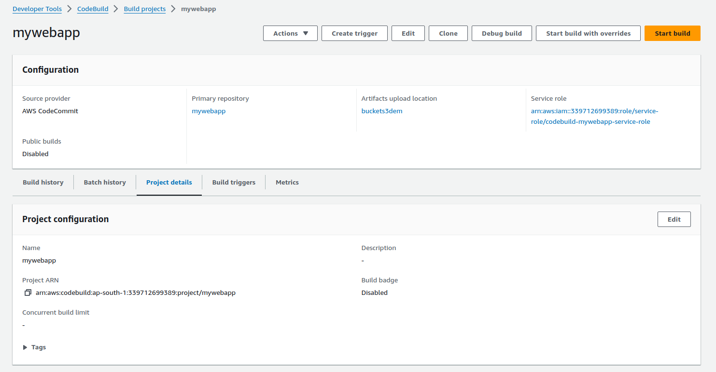

**14.Build Triggered and Successful**

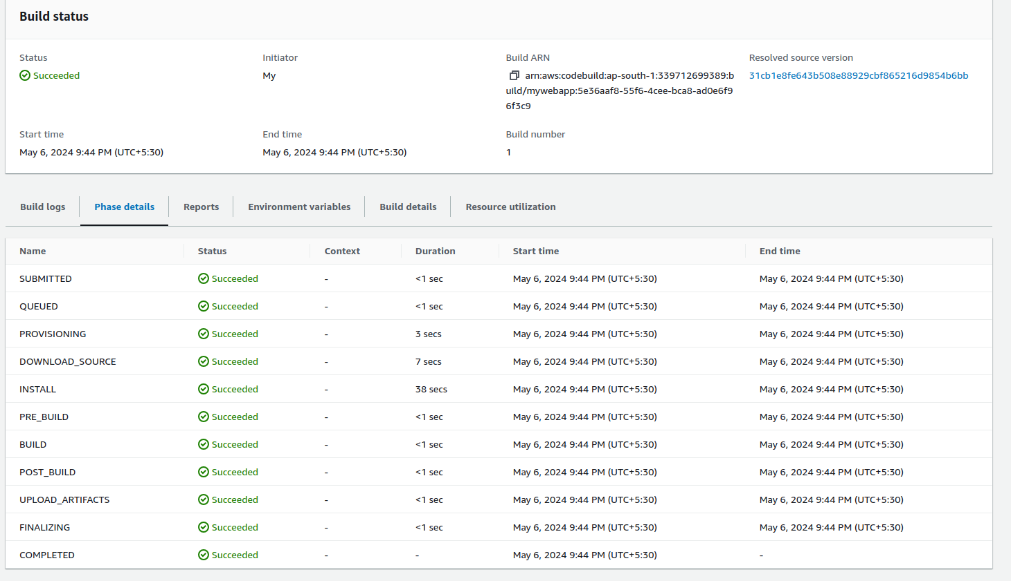

**15.Artifact stored in the Given S3 Bucket**

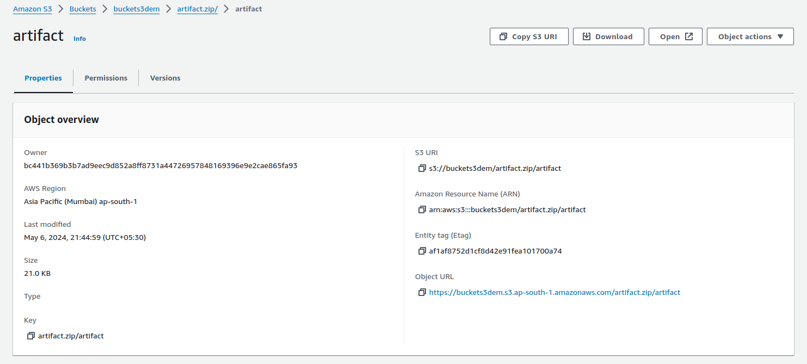

**16.Creating Application**

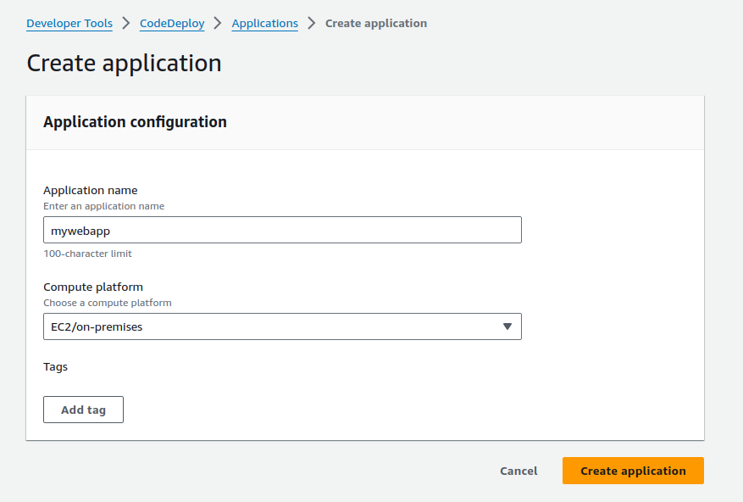

**17.nginx Appspec file**

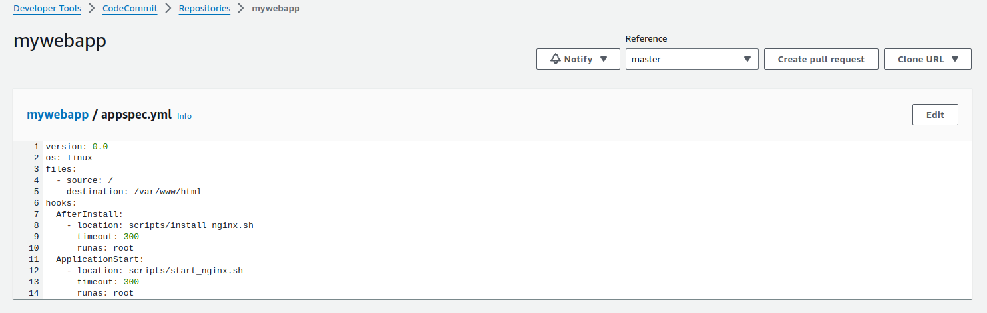

**18. nginx Files**

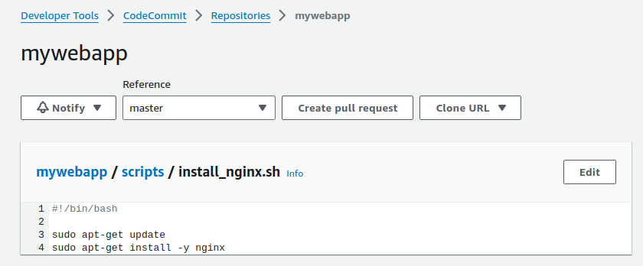

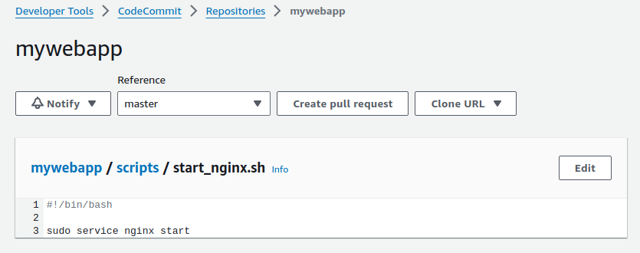

**19.Creating Deployment Group**

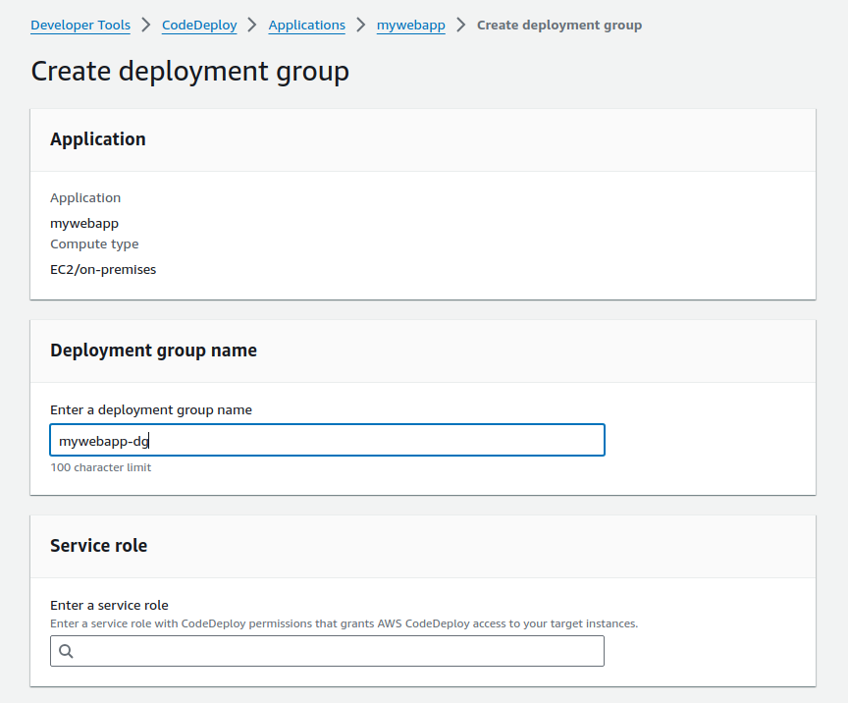

**20.Creating Role for Code Deployment**

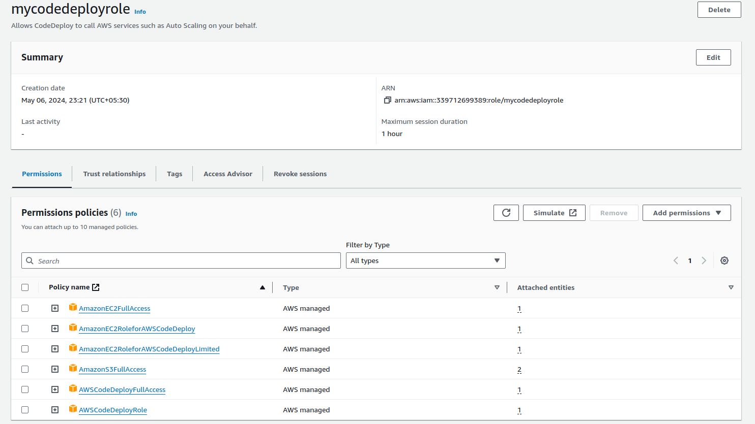

**21.Creating Role for EC2 Code Deployment**

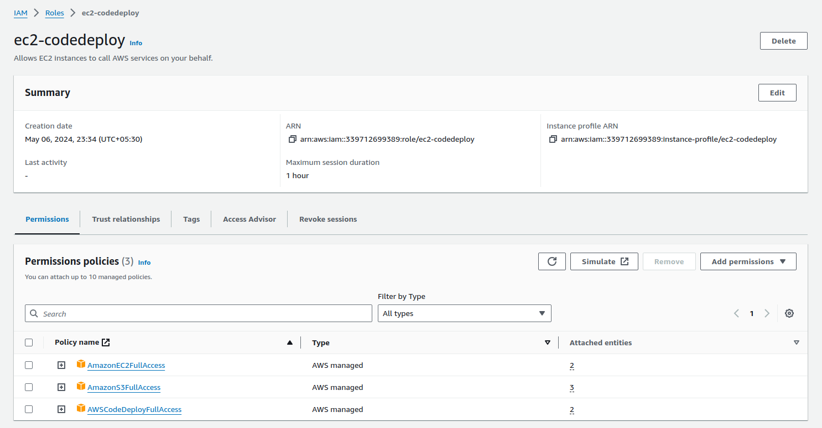

**22.EC2 Instance Created for Deployment**

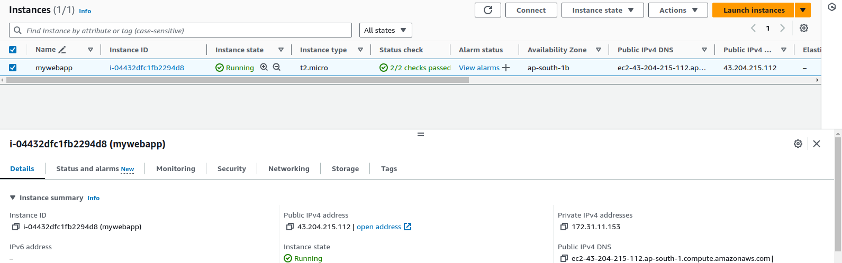

**23.Role added to the EC2**

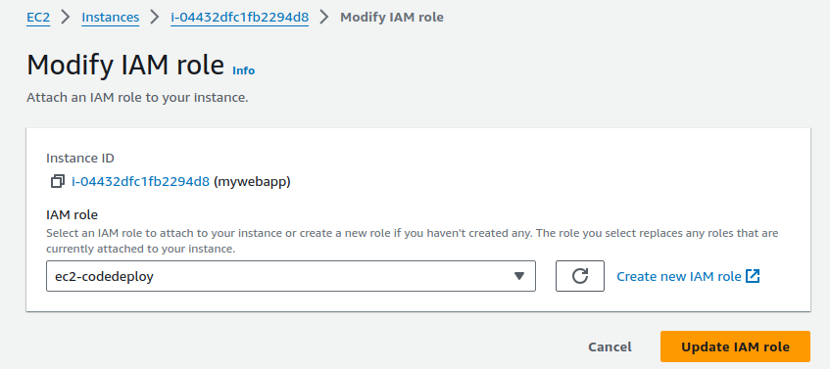

**24.EC2 Machine Launched and Creating Script file for Installing CodeDeploy agent in EC2**

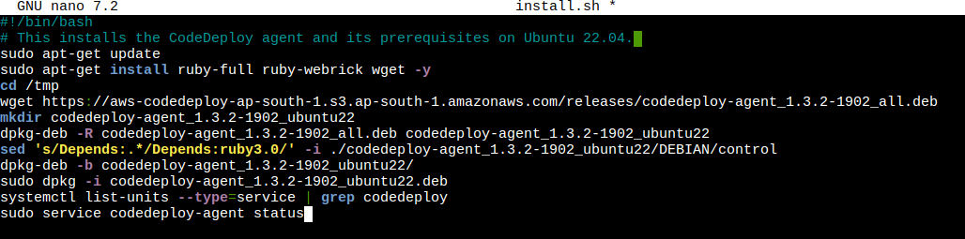

**25.Installation Triggered with Script file**

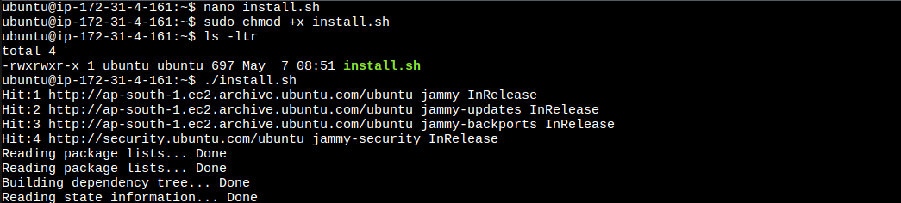

**26.CodeDeploy Agent installed in Running Up**

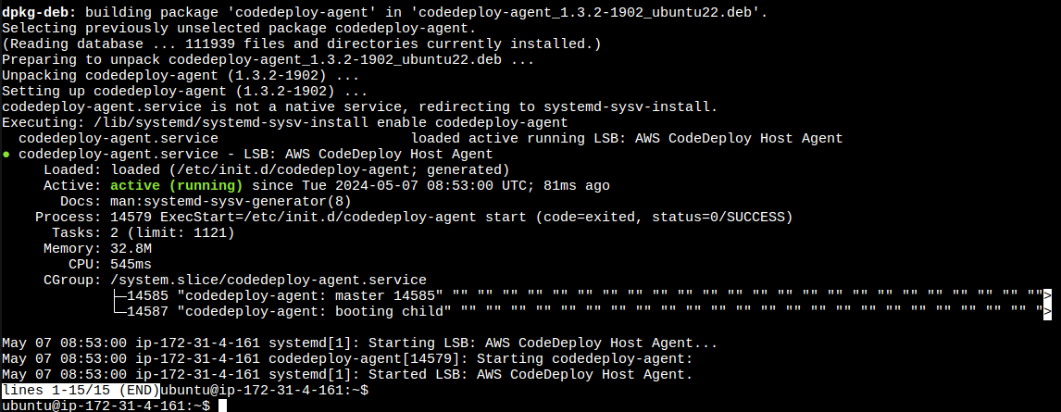

**27.Setting environment for Deploy with Created EC2**

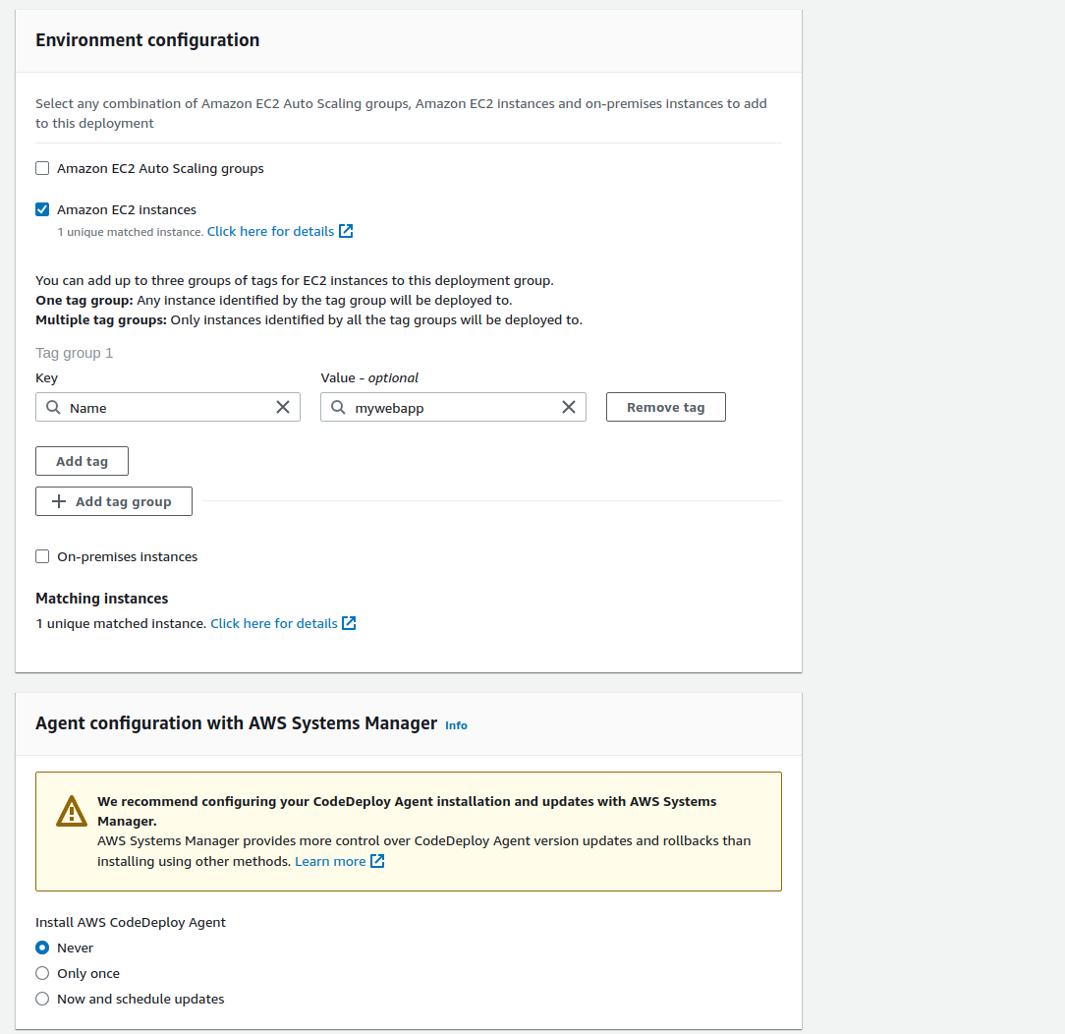

**28.Deployment Group Created**

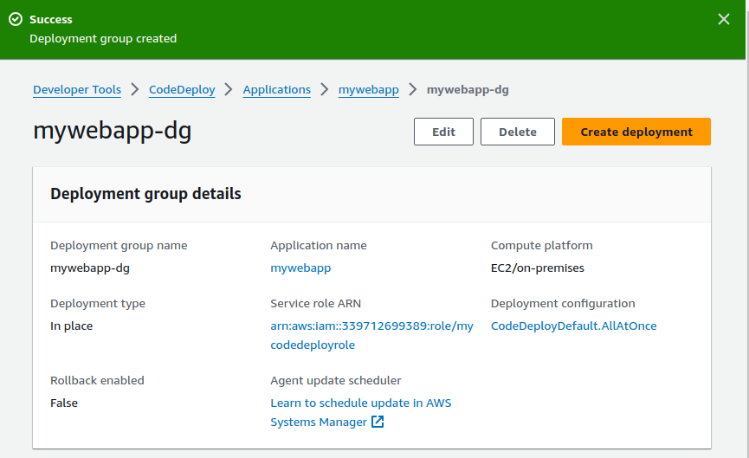

**29.Creating Deployment**

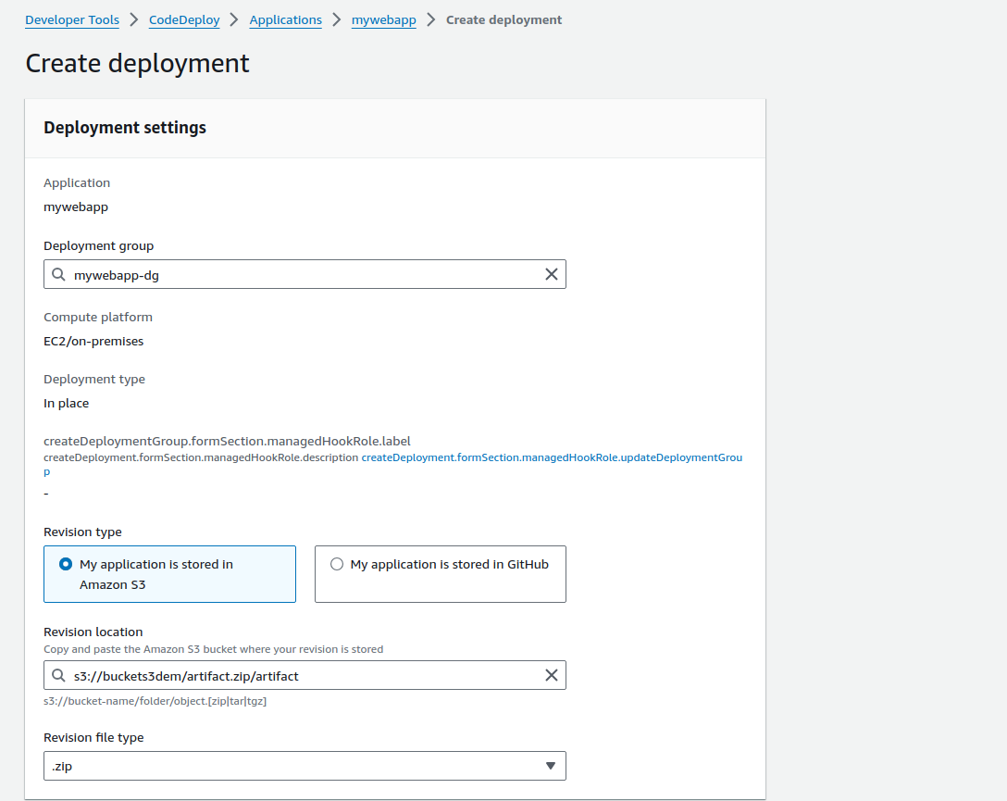

**30.S3 Bucket Artifact location copied for revision**

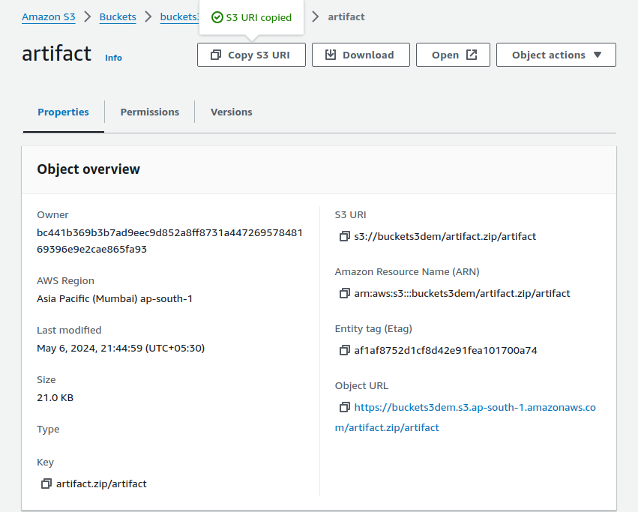

**31.Deployament Created and Triggered**

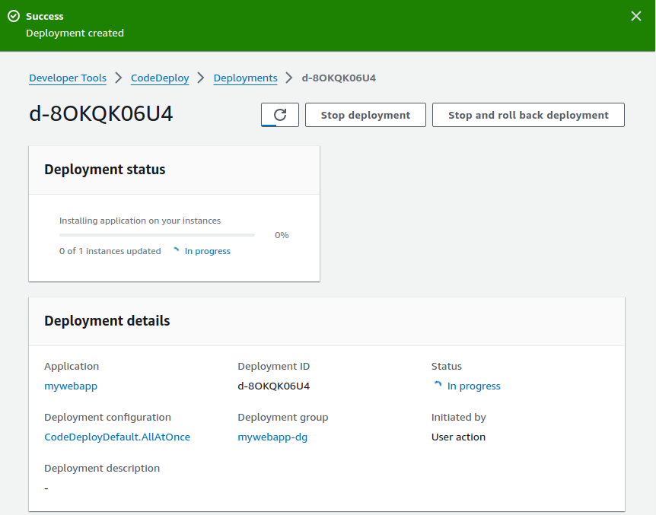

**32.Deployment Done Successful**

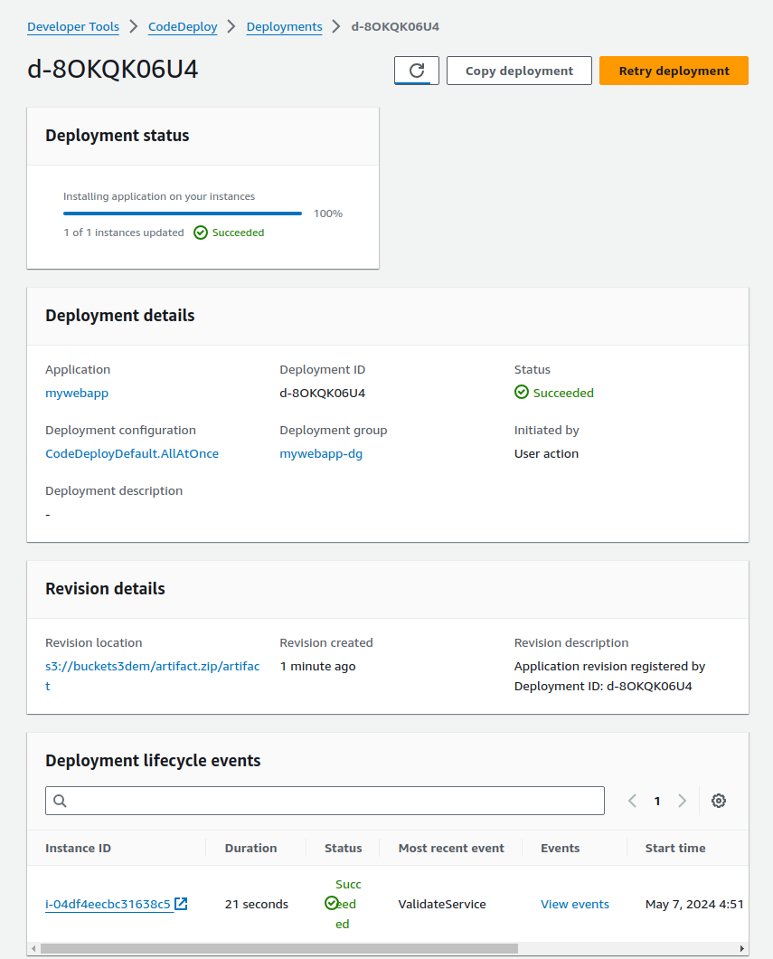

**33.Our nginx Application is Running in EC2’s Port 80**

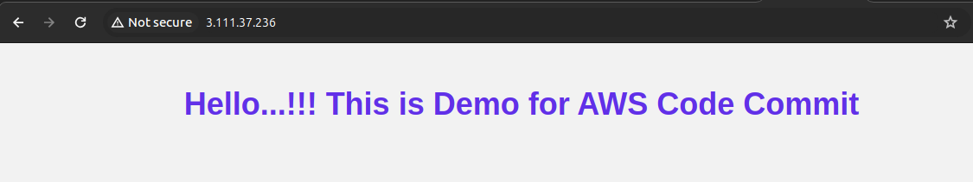

**34.Creating Pipeline settings**

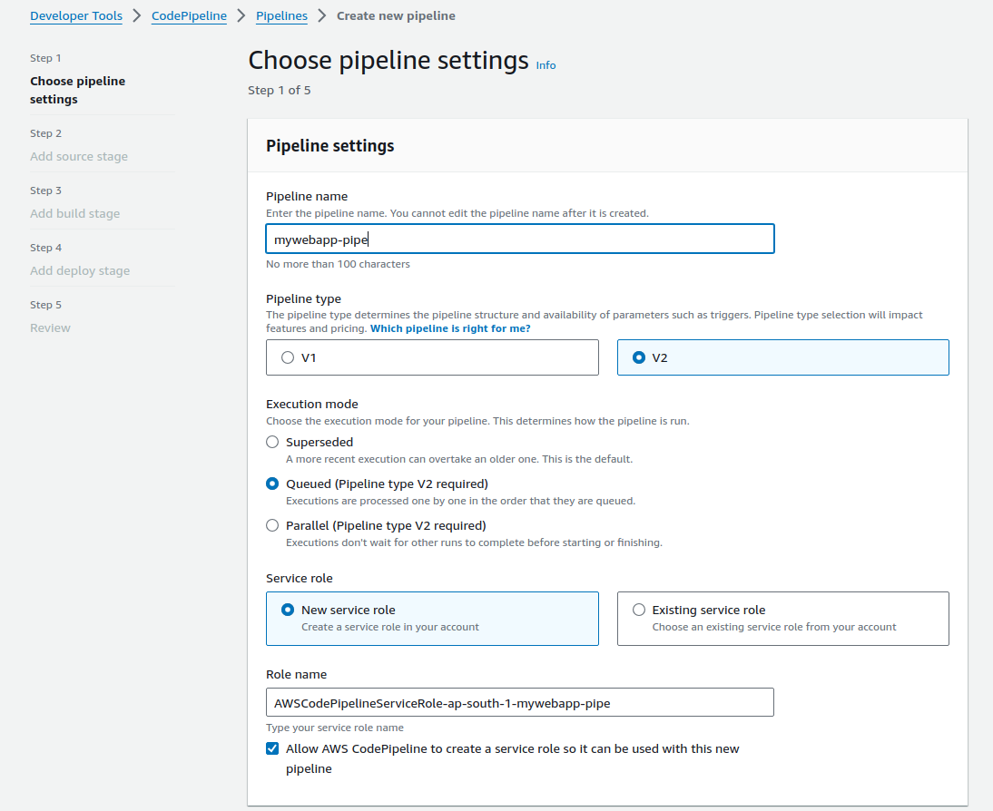

**35.Adding Source Stage**

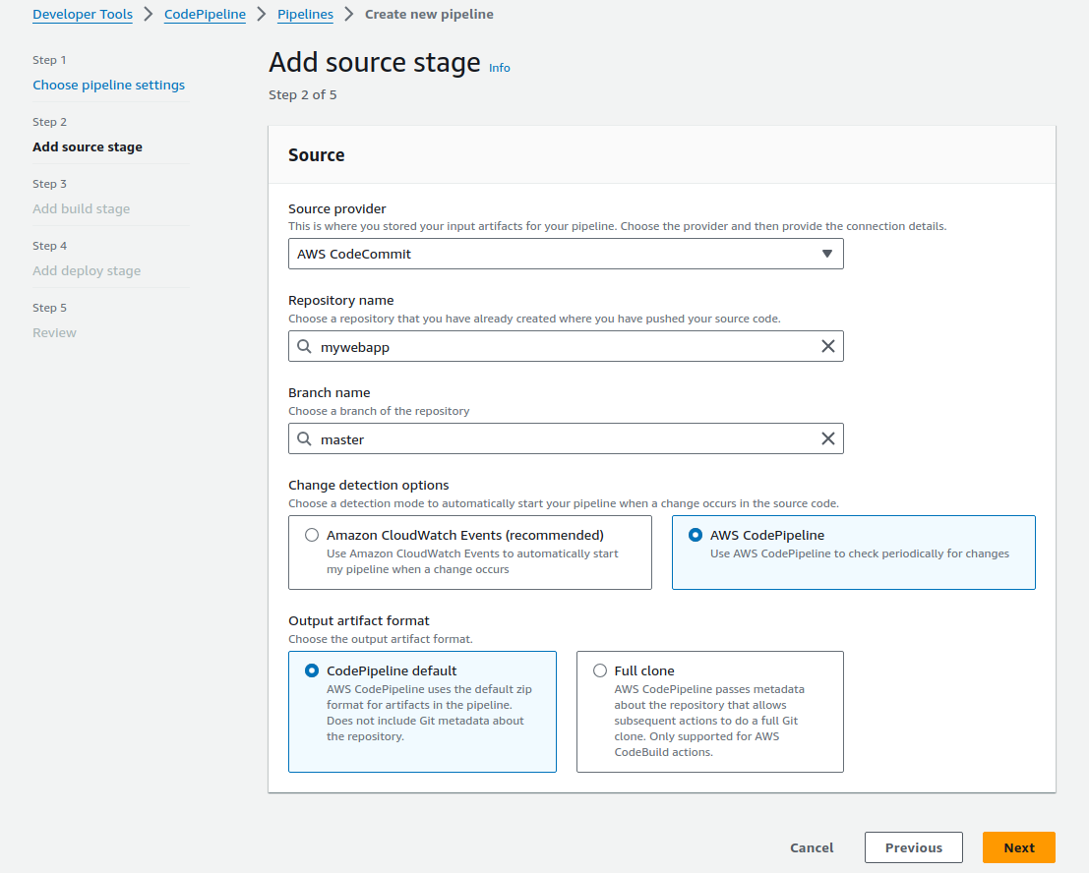

**36.Adding Build Stage**

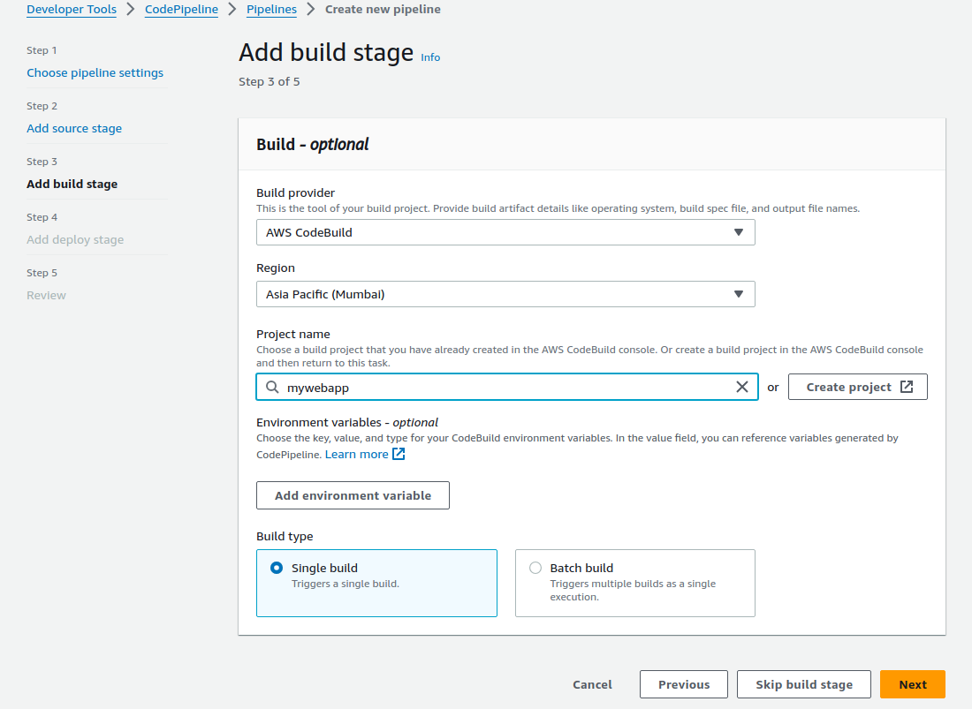

**37.Adding Deploy Stage**

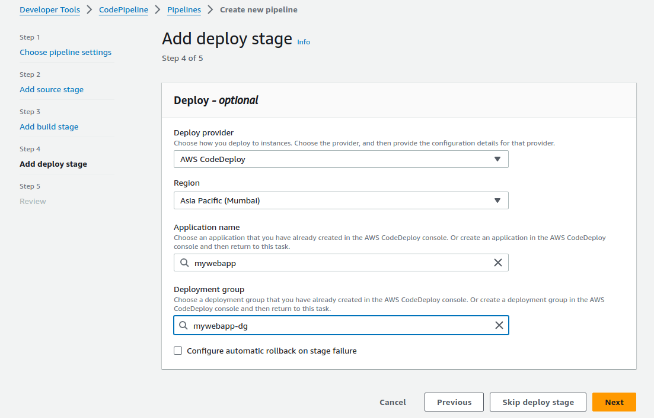

**38.Pipeline Tiggered automatically and Deployed**

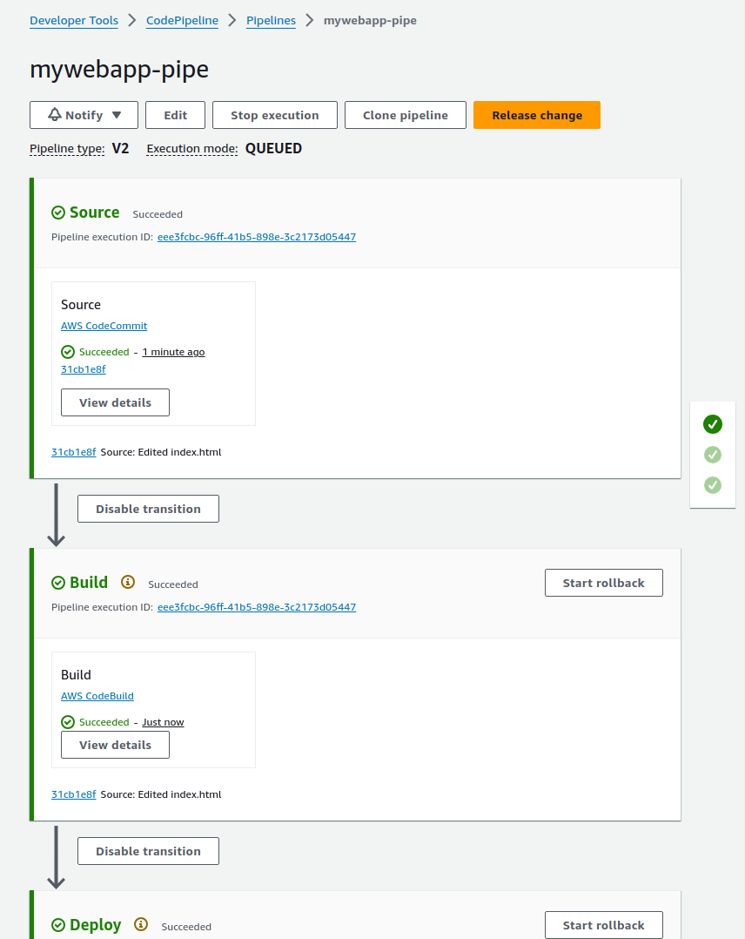

**39.New Commits made to Application in Repository**

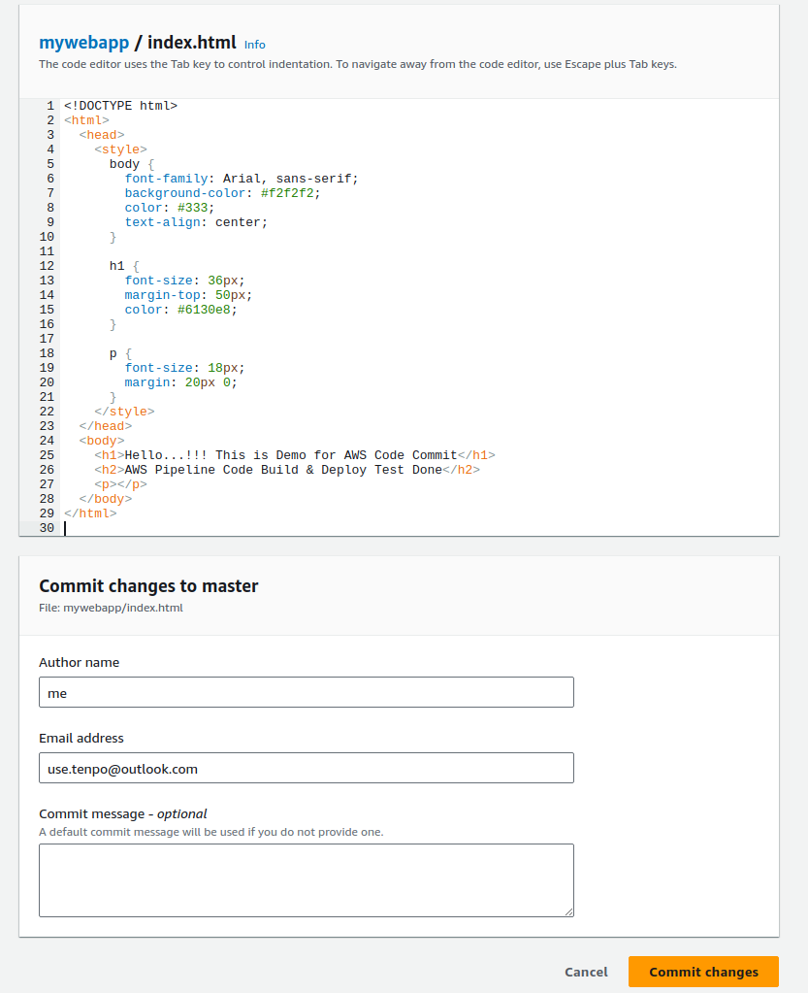

**40.Pipeline Triggered automatically after commit made in Repository**

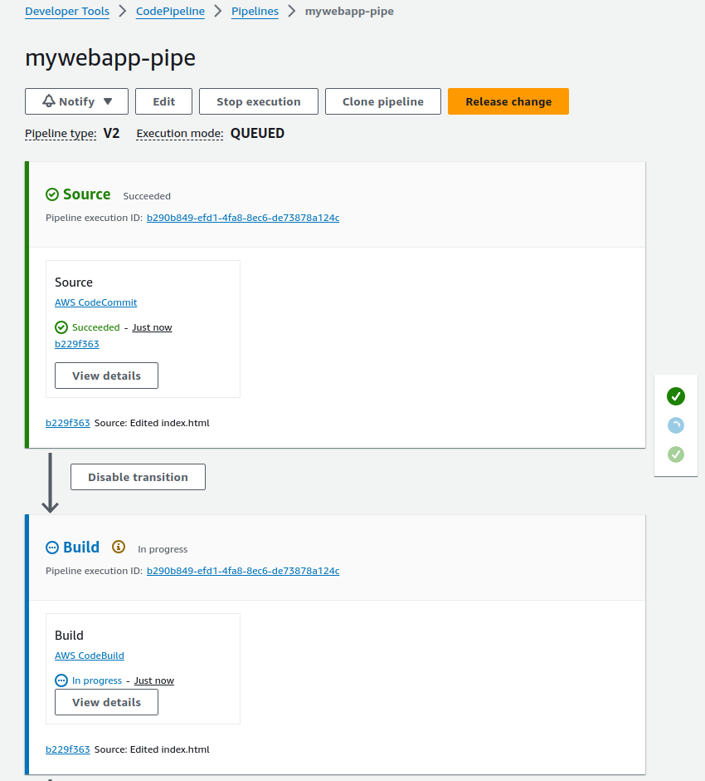

**41.Output of New Nginx Application changes deployed by Pipeline**

